Caribbean Carnival 2016
Mas Camp

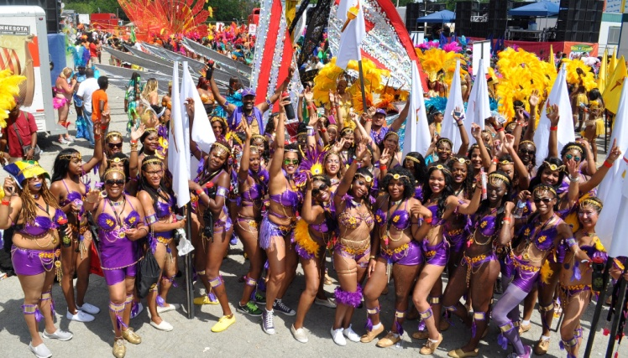
Caribbean Carnival on Saturday, July 30 is
Canada’s largest annual cultural celebration. All CUPE Ontario members are encouraged to join this year’s vibrant Parade. Join us at the open house to learn more and get measured for your very own costume.

Carnival Mas Camp Theme - “Islands in D’ Sun”
29 Commercial Road, Toronto (Eglinton and Laird)

Measurement and fitting dates at the Mas Camp:
OPEN HOUSE Sunday, June 19 5:00pm
Wednesday June 22 5pm to 9pm, Friday June 24th 6pm to 9pm
Saturday June 25th 1pm to 7pm, Sunday June 26th 1pm to 7pm,
Wednesday June 29th 5pm to 9pm, Friday July 1st 1pm to 4pm
Saturday July 2nd 1pm to 7pm
Sunday July 3rd 1pm to 7pm THIS IS THE FINAL FITTING DAY

CUPE will cover costume and refreshment costs for CUPE members.
A Limited number are available!!
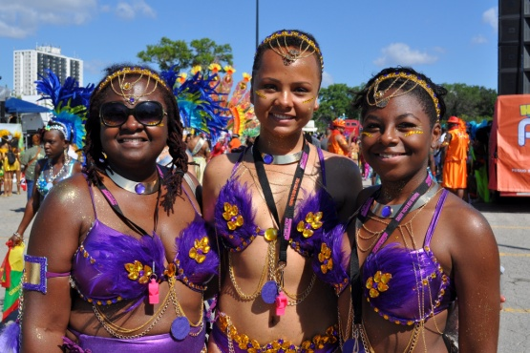
Costs for Non-CUPE members: Adults: $225 Children: $75 includes costume and refreshments

Contacts:
Sandy Heeralal-Judhan 647-309-8376 sdevih@hotmail.com
Veriline Howe 647-391-2191

COPE343

